**Name: ___________________________  
Date: ____________________________**

**Lesson 2-0: Introduction to Unit 2**

**Directions: Try all of the questions below. Remember, you might know the answers to some of them, and not know others. Try your best! I want to see our thinking before we start the unit together!**

**Our next unit is called: “Unit 2: Surface Area and Volume.”**

We will learn about **3-d figures.**

***Predict!***

* What do you think “**surface area”** is? (c*ircle one)*

*Space inside a 3-d figure Area of one of its sides Area of all of the sides of a figure*

* + How might you **calculate** the **surface area** of the following shape? Explain in words or with a picture!

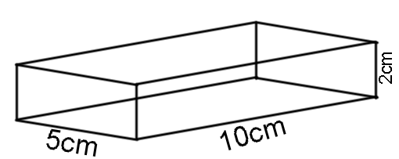

* What do you think “**volume”** is? (c*ircle one)*

*Space inside a 3-d figure Area of one of its sides Area of all of the sides of a figure*

* + How might you **calculate** the **volume** of the following shape? Explain in words or with a picture!



* **Try this! Let’s see how we do!**

***New Vocabulary!!***A **“net”** is what the figure looks like when you “unfold” all of its sides!

**Matching: match the figure in the left column to its “net” in the right column!**

|  |  |
| --- | --- |
| **Figure** | **Net** |
|  | **A** |
|  | **B** |
|  | **C** |
|  | **D** |
|  | **E** |

*How did you do?! Go online and check your answers with the key! Be ready to ask questions and share your thinking tomorrow when we start our new unit!!